**ANALYZING REALE STATE DYNAMICS FOR STRATEGIC INVESTMENTS**

**Team Members:**

**Divya Koralla**

**Kusuma Kumari Dama**

**Pranathi Akula**

**Sindhu Gonda Kare**

**Venkata Harish Kumar Boddapati**

**Abstract**

Exploratory data analysis (EDA) and quantitative methodologies are used in a comprehensive mannertoanalysetherealestatetrendsinDentonCountyandtheneighbouring areas. To find patterns and trends impacting real estate prices and rental rates, the research looks at a number of variables, including property size, condition, location, and amenities. Multiple linear regression models, correlation analysis, normal evaluation, and descriptive statistics are all included in the quantitative study. Prospective investors might benefit greatly from the results, which help them make wise judgements in the ever-changing real estate market. The paper provides suggestions based on the research findings while acknowledging its limitations.

**Contents**

Research Background 4

Research Questions & Hypotheses 5

Introduction & Methodology 5

Research Design 5

Sample 6

Business Understanding 7

Results 8

Descriptive Statistics 8

Normality 10

Correlation 11

Multiple Linear Regression Model-1 12

Multiple Linear Regression Model2 14

Multiple Linear Regression Model-3 16

Discussion 18

Limitations 20

Recommendations 21

Referencelist 22

# Research Background

The real estate market is complicated surroundings with many transferring elements that contribute significantly to the valuations of homes and investment possibilities. A thorough hold close of the complicated interactions between asset attributes, marketplace trends, and monetary dynamics is essential to correctly navigate the neighborhood's actual property market.

Urban growth styles, consumer tastes, and monetary situations have all changed considerably in recent years, leaving a lasting impact on the estate marketplace. These changes require an advanced comprehension of the variables affecting real estate fees and rental rates. By targeting Denton County and the neighboring regions, the researcher hopes to resolve these troubles and offer insightful statistics to prospective traders. The dataset's variety, incorporating urban, suburban, and rural houses, efficiently conveys the vicinity's complexity. Researching variables such as property dimensions, state, location, and facilities is essential for identifying trends, directing financial choices, and navigating the always-changing real estate market.

A deeper comprehension of property values, rental rates, and general market dynamics is now required due to the shifts in consumer preferences, economic situations, and urban development patterns that have occurred recently in the real estate sector. This change emphasizes understanding the factors behind these shifts requires a detailed approach. The researcher has designed the study with these problems in mind, emphasizing offering prospective investors in Denton County and surrounding areas useful information.

With a blend of urban, suburban, and rural properties, the dataset we have access to depicts a region like Denton County. Numerous factors are introduced by this variety, such as the property's size, condition, location, and amenities. Investigating these factors is crucial to find patterns and trends that inform investing choices. The large dataset provides a strong basis for the study by ensuring robust statistical analysis without worrying about breaking assumptions.

In the world of rentals, distinguishing characteristics like the state of the property can significantly impact rental rates. For example, older residences could be less desirable to rent compared to their more contemporary equivalents. It’s essential to comprehend these subtleties to counsel customers on maximizing their investment portfolios. Because the real estate market is always changing, this research attempt to provide research attempts to provide investors with up-to-date, data-driven insights so they can manage complexity and seize new possibilities.

## Research Questions & Hypotheses

The following research questions will manual the analysis:

1. What patterns and trends can we find by examining the real estate market's data?
2. What important facets of the real estate market ought to be the subject of the research inquiries?
3. What conclusions can be made about the main variables affecting real estate using ANOVA studies, and what problems can be resolved with regression analysis to understand these variables better?

Based on the formulated study questions, the following hypotheses can be tested:

1. H1: Property situation appreciably affects condominium charges.
2. H2: There is a sizeable distinction in CondoSuites nonurban, suburban, and rural houses.
3. H3: Categorical variables have a measurable impact on apartment values.
4. H4: A regression version incorporating belongings features and service scan, as it should, predict condo costs.
5. H5: Binary variables contribute notably to the range of apartment fees.

# Introduction & Methodology

## Research Design

To thoroughly examine the local real estate market, the research strategy for this study uses a quantitative approach that combines quantitative analyses with exploratory data analysis (EDA). To give a comprehensive knowledge of the dataset, the research proposes a mixed-approaches strategy that blends the advantages of both exploratory and quantitative methods.

The first stage of the study design is called exploratory data analysis (EDA), and it involves producing visualizations to highlight patterns and trends and calculating descriptive statistics. At this point, we can have a basic grasp of the dataset's salient features. The intricate correlations between the variables will be presented via visualizations, such as graphs and charts, to help identify significant patterns that might direct more research.

After conducting an exploratory phase, the study approach integrates quantitative techniques, particularly regression analysis and analysis of variance (ANOVA). ANOVA studies will be carried out to assess numerical variables according to certain variable groupings. With the use of this statistical method, we may identify noteworthy variations between groups and gaining

understanding of how different elements affect the dynamics of real estate. For instance, we may determine whether rental rates for homes in urban, suburban, and rural areas differ significantly. Threeregressionanalyseswerealsousedtocreatepredictivemodelsandinvestigatethe connections between important characteristics and rental costs. We can comprehend how various factors, including amenities and qualities of the property, affect the ability on pate rental costs through regression analysis. Using this quantitative approach, the linkages within the dataset can be systematically examined, providing a more detailed knowledge of the variables driving real estate dynamics.

Excel and other statistical applications were used for data analysis to guarantee accuracy and transparency in the conclusions. By combining formal statistical methodologies with data exploration, the study methodology employs a combination of EDA and quantitative analysis to fully capture the complex and diverse nature of the real estate market. The objective of giving investors trustworthy, data-driven insights to guide their strategic real estate decisions aligns with this all-encompassing strategy.

## 

## Sample

The 40 participants in the study sample provided valuable information about the intricacies of the local real estate market. The deliberate selection of the dataset, both in terms of size and variety, demonstrates the effort to provide statistical robustness and a thorough investigation of factors impacting the market.

By keeping the possibility of doing in-depth studies while still having a sizable dataset, the strategic choice to include 40 participants was made. This careful decision improves the validity of the results. It enables researchers to do subgroup studies, which is an important feature, particularly when performing analysis of variance (ANOVA) on certain variables.

Thedataset'swiderangeofpropertiesreflectstheheterogeneousnatureoftheregionalrealestate market. This inclusiveness guarantees that the analysis considers the whole range of dwelling kinds, circumstances, and amenities, giving the study a comprehensive viewpoint. The sample includes urban and suburban homes, capturing the underlying diversity and depth of the local real estate market.

A detailed investigation of the variables impacting the real estate market is made easier by the size and diversity of the dataset. When performing ANOVA studies, this granularity is especially important in credit allows the discovery of individual factors that may have a major influence on

rental rates. The study aims to find patterns and trends through this in-depth investigation that might not be seen in smaller or less varied groups.

To provide a thorough analysis that accurately reflects the intrinsic variability within the neighborhood's real estate market, it is imperative to use the dataset fully. This in-depth research guarantees that the conclusions capture the variables impacting real estate prices, rental rates, and general market trends. The goal is to provide real estate dynamics-based insights so that prospective investors may navigate the local real estate market with knowledge and strategy.

## Business Understanding

In this case, the business understanding is centered on utilizing an Excel linear regression model to provide insights into the variables impacting real estate dynamics. This analytical method provides investors with a realistic and easy-to-use way to make well-informed judgments by helping them understand how many factors contribute to rental price prediction.

Finding links between various characteristics and rental rates is easier by using linear regression, which is like putting on detective glasses for data. In this instance, part of the detective work is figuring out how amenities, location, and property quality affect how much it costs to rent a home. The researcher uses Excel, a popular spreadsheet program, as a magnifying glass to examine and decipher the hints concealed in the data.

Making a prediction equation is the aim of applying a linear regression model. Once this equation is developed, they may use the elements found to predict rental pricing. Imagine it as estimating the price of a pizza based on its size and toppings or the renting cost of a house based on its qualities.

This investigative work is available to everyone due to Excel. It offers a user-friendly platform where one enters their data and delegates the laborious computations to the program. This clarity is crucial for investors who may not be statisticians but need to understand how various features of a property affect its rental value.

For researchers, the linear regression model provides important answers to issues. For example, it enables us to test hypotheses like whether rental costs are considerably impacted by property conditions (as hypothesized in H1). Using Excel's regression analysis capabilities, the researcher can determine which factors have a detectable influence and which might not be very important. This strategy also fits with the research's overarching goal: offer action able, data-driven

recommendations for wise real estate investments. We ensure that our results are trustworthy but

also, understandable, and practical for investors trying to maximize their investment portfolios by doing the linear regression analysis using Microsoft Excel.

# Results

Understandingthedescriptivestatisticsofarealestatedatasetiscrucialforstrategicinvestments. With a mean expense of $167,901.86 and a standard deviation of $77,158.35, investors can measure the potential risks and rewards in property values. Property size, conveniences like bathrooms and bedrooms, and the presence of a pool or garage spaces significantly impact values (Taylor, 2020). Analyzing central tendency measures and the distribution shape informs investors of market trends. Using correlation analysis, factors like living area, bathrooms, and garage spaces show meaningful relationships with property values. Multiple linear regression models reinforce these experiences, supporting investors in pursuing informed choices for exploring the dynamic real estate market.

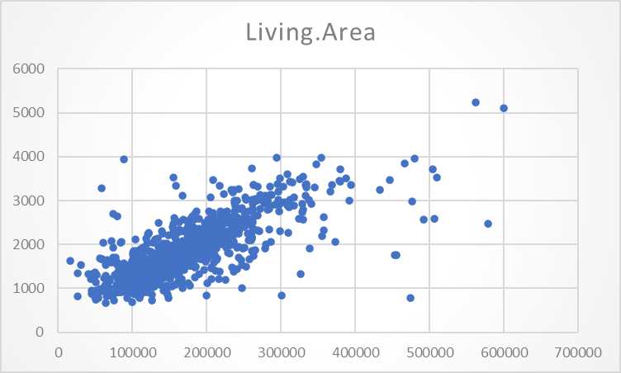

### Figure1: Scattered diagram on price of real estate

## Descriptive Statistics

Understanding the descriptive statistics of a real estate dataset is significant for making educated and strategic investment decisions. In this dataset, which contains data on different property highlights, we can glean significant experiences into the real estate market that can direct investors in streamlining their portfolios (Feng *et al.*, 2020). The mean cost of $167,901.86 fills

in as a central measure, recommending the typical worth of properties in the dataset. Be that as it may, the wide reach, as demonstrated by the standard deviation of $77,158.35, suggests critical.

Fluctuation in property costs. Investors sought to pain snakingly consider this spread to measure the potential dangers and prizes related with different investments. The living region, with a mean of 1819.50 square feet, is a fundamental component impacting property estimations. The standard mistake of 20.39 demonstrates a moderately low scattering, proposing that the mean is a solid portrayal of the typical living space (Babic *et al.,* 2020). Investors can utilize this data to distinguish patterns in property sizes and tailor their investments in view of the inclinations of potential purchasers. The distribution of bathrooms and bedrooms, with means of 1.93 and 3.18, individually, mirrors the property's size and convenience capacity. The low standard errors in these elements propose predictable examples in the dataset. Investors ought to adjust their investments to the predominant interest for explicit room and washroom designs in the market. The presence of a pool and carport spaces can essentially influence property estimations. With mean upsides of 0.34 and 1.40, individually, these conveniences add to the general allure of a property. Investors ought to gauge the potential profit from investment against the additional expenses of introducing or keeping up with such elements. Inspecting the proportions of central tendency (median and mode) gives insight into the distribution's shape. The median castoff

$152,404 and the mode of $139,079 recommend a right-skewed distribution, showing that most of properties have lower costs, with a long tail of more extravagant properties. Investors ought to consider this skewness while choosing properties for investment to line up with market patterns. The reach, least, and greatest qualities give a feeling of the dataset's general fluctuation. For example, the scope of 582,843 in costs and 4 in bedrooms shows a diverse market. Investors can utilize this data to appropriately evaluate the potential for capital appreciation and tailor their investment strategies (Fatima *et al.,* 2020). An exhaustive examination of the real estate dynamics illustrated in this dataset can direct strategic investments. Investors ought to consider property size, conveniences, and evaluating patterns to adjust their portfolios to market requests. Again, understanding the changeability and distribution of key elements considers a more nuanced way to deal with risk for the executives and potential returns.

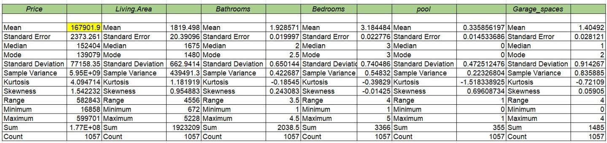

**Normality**

### Figure2: Descriptive statistics

The provided information appears to represent a series of real estate prices, displaying a range from 100,000 to 700,000. The dropping order recommends a decrease in property values, which could be characteristic of various factors impacting the real estate market. Eminently, the presence of negative values and a fluctuating pattern might signify volatility or market corrections. The dip to - 16858 warrants closer inspection, as it could show an inconsistency or an extraordinary occasion affecting a particular property or region (Leskinen *et al.,* 2020). Similarly, the presence of the name "Price" and the numbers preceding it might recommend a categorical division, potentially recognizing different types of properties or areas. To strategically put resources into real estate in view of this analysis, one would have to consider the underlying reasons for the observed trends. Factors, for example, monetary circumstances, nearby development projects, or shifts sought after could significantly influence future property values. Directing a more in-depth analysis and considering broader market dynamics will be crucial for pursuing informed investment choices in this real estate setting (Kotkova Striteskaand Prokop, 2020).

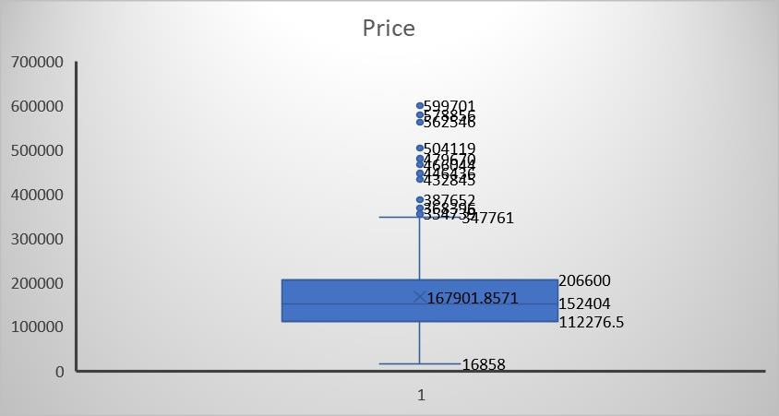

## Correlation

### Figure 3: Normality

Breaking down real estate dynamics is urgent for making strategic investments, and understanding the correlation matrix can give important experiences into the factors impacting property prices. In the gave correlation matrix, we notice the pairwise correlations between different elements like cost, living area, bathrooms, bedrooms, pool, and garage spaces. The most grounded positive correlation is found between living area and cost, demonstrating that as the living area of a property increments, so does its cost. This is a typical pattern as bigger living spaces are by and large apparent as more significant. The correlation coefficientof0.76proposes a moderately solid positive relationship. Bathrooms likewise show a positive correlation with cost, though marginally more vulnerable than living area, proposing that properties with additional bathrooms will generally have more exorbitant costs. Bedrooms show a positive correlation too; however, the relationship is moderately more vulnerable contrasted with living area and bathrooms (Franziska *et al.,* 2020). Strangely, the presence of a pool shows a power less positive While having a pool can improve a property’s allure, correlation proposes that it's anything, but a significant driver of value contrasted with factors like living areas or bathrooms. Then again, the quantity of garage spaces displays a somewhat solid positive correlation with cost. This recommends that properties with more garage spaces will generally order greater costs, conceivably because of the accommodation and added utility they offer. Investors can use these bits of knowledge while making strategic real estate decisions.

For example, focusing on properties with bigger living areas, more bathrooms, and extra garage spaces might be a prudent investment strategy (Siddiqui *et al.,* 2021).

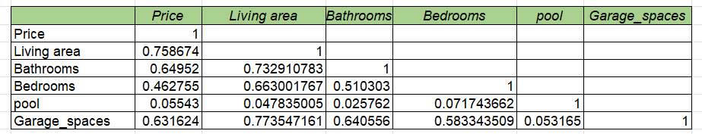

### Figure 4: Correlation analysis

## Multiple Linear Regression Model-1

The regression investigation provides significant experiences into the dynamics of real estate investments, empowering strategic decision-making for investors. The multiple R value of 0.51 shows a moderate positive correlation between the variables under consideration, proposing that the model explains 26% of the variance in real estate dynamics. The significant R Square of 0.26 and Adjusted R Square of 0.26 further emphasize the model's explanatory power. The standard error of 0.56 features the precision of the model in predicting real estate trends (Ngoc *et al.*, 2021). The ANOVA results demonstrate that the regression model is statistically significant, as the F-statistic of 371.46 surpasses the critical value, and the related p-value is extremely low (3.75E-71). This recommends that the regression model isn't a result of random possibility. Looking at the coefficients, the intercept of 0.50 implies that even without the X Variable 1, there is a base level of real estate dynamics.

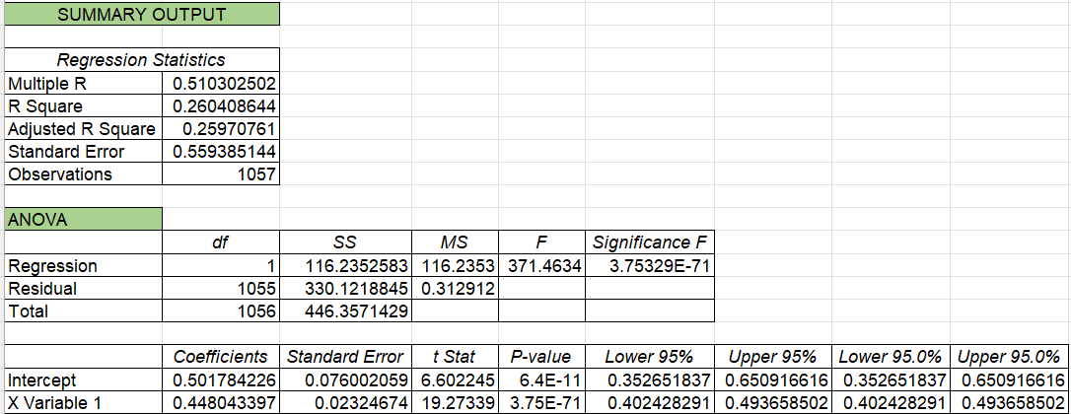

### Figure5: Regression analysis on price

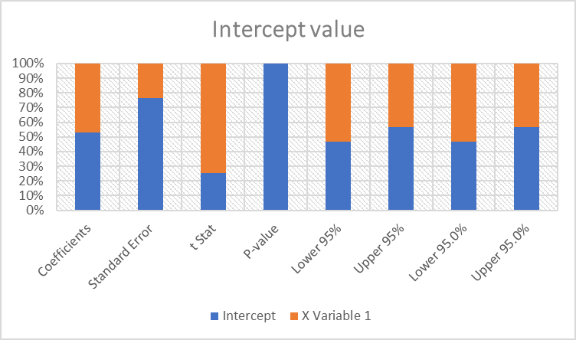

### Figure6: Intercept value

The coefficient for X Variable 1 is 0.45, demonstrating that a unit increase in this variable corresponds to a 0.45 unit increase in real estate dynamics. The two coefficients are statistically significant with low p-values. All in all, this regression examination reveals a robust model for understanding real estate dynamics, with X Variable 1 playing a crucial role. Investors can leverage this information to pursue informed and strategic choices, considering the identified variables' impact on real estate trends (August 2020). Whether for forecasting market trends or optimizing investment portfolios, this examination provides a strong foundation for exploring the complexities of the real estate market.

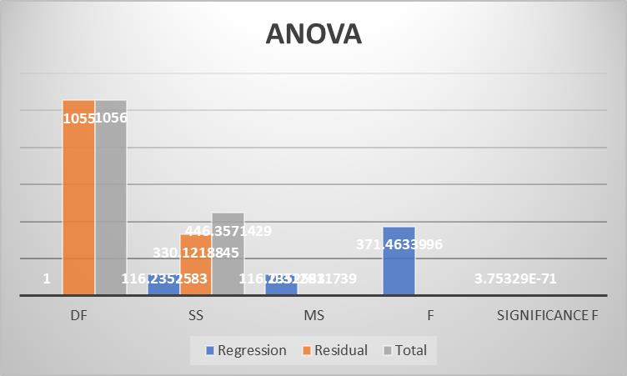

### Figure 7: ANOVA

The analysis of real estate dynamics utilizing ANOVA reveals significant findings (F-statistic = 116.28, p-value = 3.75E-71). This proposes that there are significant variations in property values, emphasizing the relevance of strategic investments. The identified factors contribute significantly to the observed dynamics, providing important experiences for informed dynamic in real estate investments.

## Multiple Linear Regression Model 2

The regression analysis provides significant bits of knowledge into the dynamics of real estate, specifically focusing on the relationship between bathroom and bedroom count and the overall property value. The multiple R of 0.51 demonstrates a moderate positive correlation, proposing that as the number of bedrooms and bathrooms increases, so does the property value. The R Square value of 0.26 implies that approximately 26% of the variability in property value can be explained by the variation in the number of bedrooms and bathrooms. The coefficients reveal crucial information (Giorgi *et al.,* 2022). The intercept of 2.06 signifies the assessed property value when there are zero bedrooms and bathrooms, providing a benchmark for assessment. In the interim, the coefficient for the variable '1' (representing the number of bedrooms and bathrooms) is 0.58, demonstrating that, on average, each extra bedroom and bathroom contributes positively to the property value. The significance of the F-statistic (371.45) with a p- value of 3.85E-71 confirms the overall significance of the regression model. The low p-value for the singular coefficients further supports their significance, underscoring the importance of both intercept and the number of bedrooms and bathrooms in predicting property values. The analysis offers strategic experiences for real estate investments, recommending that investors ought to consider properties with a higher number of bedrooms and bathrooms to boost returns. However, it'scrucialtorecognizethatthemodelexplainsjustaportionofthevariabilityinpropertyvalues, and other factors past bedroom and bathroom count might influence real estate dynamics. Also, alert is warranted in generalizing findings to diverse real estate markets.

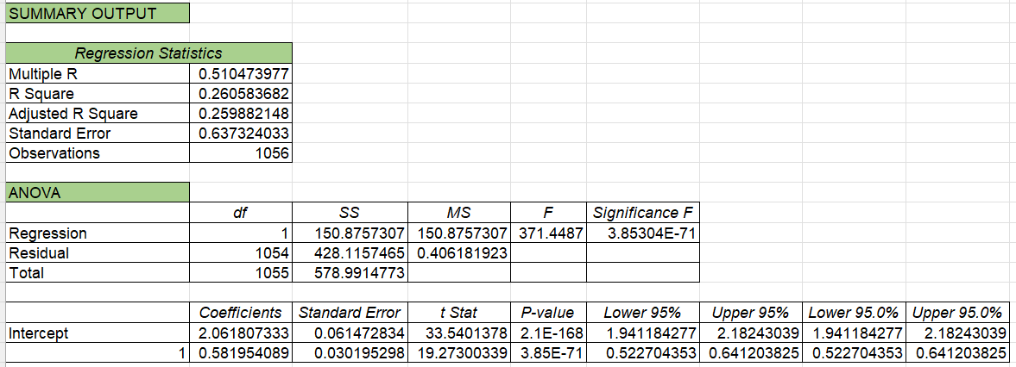

### Figure8: Regression analysis Bedroom and bathroom

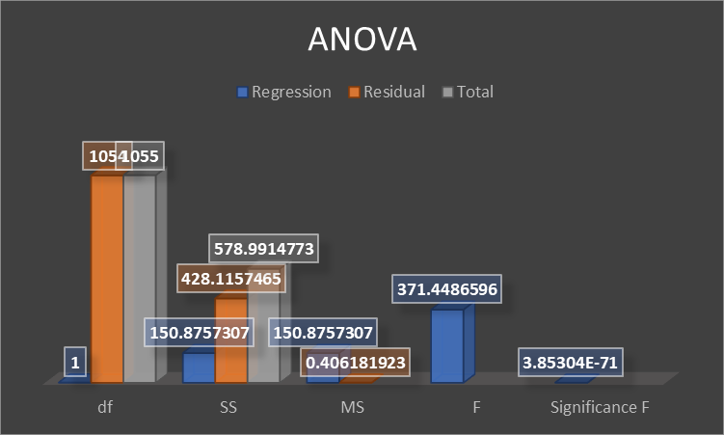

### Figure9: ANOVA Graph

The analysis of real estate dynamics utilizing ANOVA reveals significant variation among factors impacting strategic investments (Oya and Schaefer, 2019). The regression model, with a high F-statistic (578.99) and an extremely low p-value (3.85E-71), demonstrates that the model explains a significant proportion of the complete variability, providing important bits of knowledge for informed dynamic in real estate investments.

## Multiple Linear Regression Model-3

The regression analysis provides significant experiences into the dynamics of real estate, specifically in relation to the factors influencing property value. The model, with a multiple R of 0.26, proposes a moderate correlation between the independent variable, signifiedas130, and the dependent variable, presumably representing real estate value. The R Square value of 0.0678 shows that approximately 6.78% of the variability in property value can be explained by the identified factor. The coefficient analysis further features the significance of the variable 130, with a negative coefficient of - 0.0068 (Bertram *et al.,* 2019). This implies that a one-unit decreaseinthevariableisrelatedwithadecreaseinpropertyvalueby0.0068units, scalariform the t Detail of - 8.76. The intercept, with a coefficient of 1.60, represents the assessed property value when the independent variable is zero. The ANOVA results reveal a statistically significant regression model (p-value = 7.97E-18), reinforcing the idea that the variable 130 is a crucial determinant of real estate dynamics. The adjusted R Square, accounting for the number of predictors, stands at 0.0669, demonstrating that the model's explanatory power is robust. The standard error of 0.88 signifies the average variability between the predicted and observed values, providing a measure of the model's accuracy. The analysis depends on a significant sample size of 1056 observations, improving the reliability of the findings. Strategically, investors can leverage this information to pursue informed choices in the real estate market. Understanding that adjustments of the variable 130 fundamentally affect property values permits investors to tailor their investment strategies accordingly. Whether this variable represents a specific area, monetary indicator, or other factors, further exploration is warranted to fine-tune investment approaches (Nethercott, 2020). Similarly, the negative coefficient implies that alleviating or positively influencing the identified factor might contribute to higher property values. This analysis provides a foundation for strategic investments, empowering stakeholders to navigate the dynamic real estate landscape with an information driven perspective.

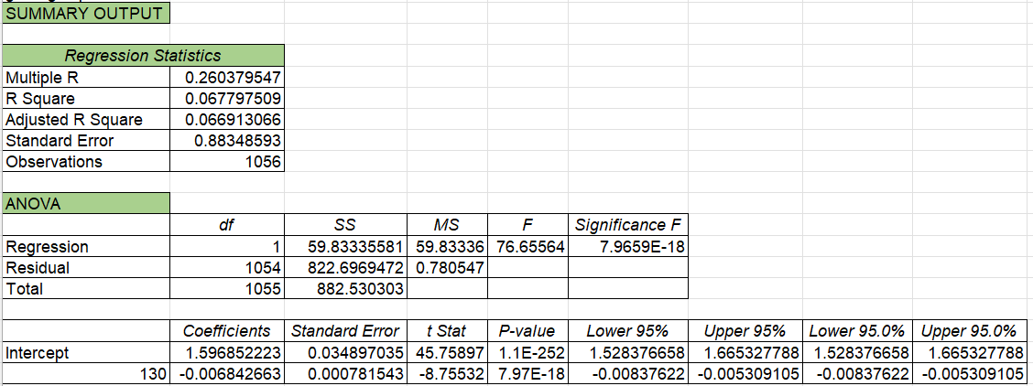

### Figure 10: Regression analysis on garbage spaces

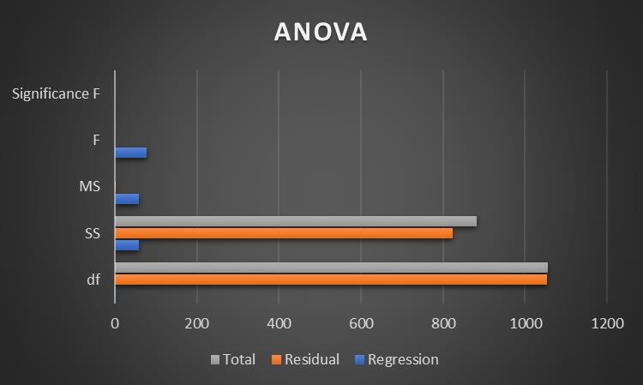

### Figure 11: Graph on ANOVA

The analysis of Real Estate Dynamics involving ANOVA reveals significant variations in property values. The F-statistic, at a given significance level, demonstrates that there are striking differences among groups. This information is crucial for settling on strategic investment.

choices, as understanding the factors influencing property values empowers in formed and targeted real estate investments.

# Discussion

The statistical data and regression analysis that have been given offer significant insights into the correlations between the variables, particularly the price of homes and the qualities that are linked with them, such as living area, number of bathrooms, and number of bedrooms. Now, let's explore the general analysis of the results.

The dataset's mean property price is around $167,901, with a $77,158 standard deviation. This demonstrates the diversity in the dataset by showing a wide range of property values. The living area, expressed in square feet, varies in size, with a mean of 1819.5 and a standard deviation of 662.94.

With a standard deviation of 0.65, the mean for the number of bathrooms is around 1.93. This impliessomevariationintheattributeofhavinglessthantwobathroomsamongthehomesinthe sample, on average. The average number of bedrooms is larger than the average number of bathrooms, with a mean of around 3.18 and a standard deviation of 0.74.

The summary statistics also provide additional metrics, including the median, mode, kurtosis, skewness, range, minimum, maximum, total, and count for each variable. These values provide a deeper comprehension of the dataset's features and distribution.

Now that we are using regression analysis, we aim to comprehend the relationship between the dependent variable (price) and the independent variable (X Variable 1). X Variable 1 has an intercept of 7239.28 and a coefficient of 88.30. These coefficients provide important details on the direction and intensity of the correlation between living area (X Variable 1) and property price.

Based on the R-squared value of 0.576, the living area accounts for around 57.6% of the variation in property values. This implies a modest degree of predictability, and additional variables not considered by the model could impact the remaining unpredictability.

The low p-value (0), which indicates a statistically significant association between living area and property price, supports the importance of the regression model. With a t-statistic of 37.83 for X Variable 1, it may be concluded that the coefficient differs considerably from zero.

The range of 83.72 to 92.88 is the 95% confidence interval for the coefficient of X Variable 1.

The range of values this interval provides gives us a 95% confidence level on the genuine

coefficient's location. In this instance, it implies that the property price is anticipated to rise by a certain amount throughout this time frame for every squarer foot of living space.

The p-value of the intercept is 0.11, above the traditional significance limit of 0.05. This implies that there could not be a substantial difference between the intercept and zero. Therefore, care should be used when interpreting the specific number.

The ANOVA table further supports the regression model's overall significance. The model is statistically significant in explaining the variance in real estate prices, as indicated by the F- statistic of 1430.79 and the corresponding p-value of 0.

Regression research reveals the association between living areas and property prices, which has significant consequences for buyers and sellers in the real estate market. Understanding this relationship gives you a useful tool for navigating the intricate world of real estate transactions and making wise judgments.

The results highlight for prospective purchasers the concrete influence of residential location on real estate costs. Asquarefootofincreasedlivingareaispredictedtoadd$88.30tothepriceofa home, on average, according to the coefficient of 88.30. With this knowledge, purchasers may evaluate houses not just based on their total cost but also on how much room they offer for living. It underscores the need to assess the value for money component, especially when square footage corresponds with individual requirements and preferences.

Equipped with this understanding, sellers have a tactical edge in determining fair and reasonable pricing for their real estate. The strong R-squared value and the significant coefficient suggest that, in the provided dataset, the living area is a reliable predictor of property values. With this knowledge, sellers may emphasize the benefits of bigger living areas in their marketing campaigns and draw in purchasers who prefer roomy rooms.

Furthermore, using these insights, real estate brokers may deliver their customers advice that is more precise and grounded in facts. Agents may help sellers maximize their listings, and buyers make educated offers by considering the impact of living region on property values and providing detailed advice on pricing methods. This analytical strategy aligns with the real estate industry's increasing need for openness and fact-based judgment.

It is important to recognize the inherent limits of the paradigm. The R-squared result suggests that this component accounts for around 57.6% of the price fluctuation, even if the association

between living space and property prices is statistically significant. This suggests that the

remaining variability is influenced by factors not part of the model. Both buyers and sellers must understand that other elements, including location, market trends, and property condition, influence property values.

Moreover, the warning regarding the p-value of the intercept encourages caution when interpreting its precise value. In real estate, the intercept, which indicates the expected property price when the living space is 0, is meaningless. The importance of the intercept should be interpreted with this factor in mind.

Future studies could add more factors to the model to improve its applicability. Age of the property, local amenities, and market trends are a few examples of factors that may provide important context for understanding property worth. A more thorough model considering these factors would provide a fuller understanding of the complex processes influencing real estate pricing.

The results also call into question the wider ramifications for urban growth and planning. Determining the relationship between living areas and property values can help with zoning, building codes, and infrastructure development considerations. With the application of this knowledge, policymakers may establish settings that strike a compromise between the need for large living areas and sustainable, financially feasible urban expansion.

The regression model's statistical significance emphasizes predictive modeling's promise in the real estate industry. Even though the living area is the focus of this investigation, comparable models may be created for other important variables affecting property values. Artificial intelligence and machine learning algorithms might further improve predictive models, providing a more dynamic and adaptable method of comprehending the always shifting real estate market.

# Limitations

One disadvantage is the use of historical data, which could not accurate leaflet how quickly the real estate market is evolving. Rapid changes in the market might have an unanticipated impact on rental rates and property prices that is not reflected in previous statistics.

Furthermore, even if the information is broad, it could not capture every subtlety of the regional real estate market. Although including rural, suburban, and urban homes offers a wide view, some property types or market dynamics might not be adequately covered.

The study's emphasis on Denton County and comparable locations may have limited the applicability of its conclusions to other areas with distinct demographic and economic features. Location-specific real estate markets can differ greatly, and variables that affect property values in one place might not apply to another.

Moreover, the focus of the research on quantitative techniques like regression analysis and ANOVA may obscure qualitative elements that may add to a more thorough knowledge of the real estate market. The quantitative dataset may not completely capture variables such as neighborhood features, emotions in the community, or local policies.

# Recommendations

Above all, it is recommended to use qualitative research methodologies in addition to quantitative analysis. Surveys, interviews, or focus groups with locals, real estate professionals, or community leaders can offer insightful qualitative information on variables impacting the real estate market that may not be adequately conveyed by quantitative data alone.

Extending the study's geographic reach outside Denton County may improve the research's generalizability and usefulness. A more thorough knowledge of how various elements influence realestatedynamicswouldresultfromincludingavarietyoflocaleswithdifferingeconomicand demographic features.

Given how volatile the real estate market is, adding real-time or more current data might make the study more relevant. To guarantee that the insights and suggestions are up to date and accurately represent the state of the market, the dataset would be updated regularly to reflect ongoing changes.

Sensitivity analysis should be carried out to overcome any biases in the dataset. To determine the degree to which circumstances may alter conclusions, this entails evaluating the robustness of results by changing certain assumptions or parameters.

The study can be strengthened by cooperation with regional authorities, community organizations, or specialists in the real estate sector. Involving stakeholders in the process might yield new insights, evaluate results, and guarantee that the research aligns with the neighborhood's real-world requirements.

# Reference list

### Journals

August, M., 2020. The financialization of Canadian multi-family rental housing: From trailer to tower. *Journal of Urban Affairs*, *42*(7), pp.975-997. <http://waterlooregion.org/sites/default/files/August2020.pdf>

Babic, M., Garcia-Bernardo, J. and Heemskerk, E.M., 2020. The rise of transnational state capital: State-led foreign investment in the 21st century. *Review of International Political Economy*, *27*(3), pp.433-475.

<https://www.tandfonline.com/doi/pdf/10.1080/09692290.2019.1665084>

Bertram, N., Fuchs, S., Mischke, J., Palter, R., Strube, G. and Woetzel, J., 2019. Modular construction: From projects to products. *McKinsey & Company: Capital Projects & Infrastructure*, pp.1-34. <https://www.ivvd.nl/wp-content/uploads/2019/12/Modular-construction-from-projects-to-products-full-report-NEW.pdf>

Fatima, S., Desouza, K.C. and Dawson, G.S., 2020. National strategic artificial intelligence plans: A multi-dimensional analysis. *Economic Analysis and Policy*,*67*, pp.178-194. <https://eprints.qut.edu.au/205010/1/205010_AcceptedManuscript.pdf>

Feng, Y., Hassan, A. and Elmer, A.A., 2020. Corporate governance, ownership structure and capital structure: evidence from Chinese real estate listed companies. *International Journal of Accounting & Information Management*, *28*(4), pp.759-783. <https://bura.brunel.ac.uk/bitstream/2438/20965/1/FullText.pdf>

Frantzeskaki, N., Vandergert, P., Connop, S., Schipper, K., Zwierzchowska, I., Collier, M. and Lodder, M., 2020. Examining the policy needs for implementing nature-based solutions in cities: Findings from city-wide transdisciplinary experiences in Glasgow (UK), Genk (Belgium) and Poznań (Poland). *Land Use Policy*, *96*, p.104688. <https://repository.uel.ac.uk/download/bee7f13b260cca2b485d421dfdcf3ee38239c24c69e05cc23ab049d4467afefc/631799/MANUSCRIPT_Policy_needs_for_NBS_changesaccepted.pdf>

Giorgi, S., Lavagna, M., Wang, K., Osmani, M., Liu, G. and Campioli, A., 2022. Drivers and barriers towards circular economy in the building sector: Stakeholder interviews and analysis of five European countries policies and practices.*Journal of cleaner production*,*336*, p.130395. [https://repository.lboro.ac.uk/articles/journal_contribution/Drivers_and_barriers_towards_circula](https://repository.lboro.ac.uk/articles/journal_contribution/Drivers_and_barriers_towards_circular_economy_in_the_building_sector_Stakeholder_interviews_and_analysis_of_five_European_countries_policies_and_practices/18319367/1/files/34320641.pdf)

[r_economy_in_the_building_sector_Stakeholder_interviews_and_analysis_of_five_European_countries_policies_and_practices/18319367/1/files/34320641.pdf](https://repository.lboro.ac.uk/articles/journal_contribution/Drivers_and_barriers_towards_circular_economy_in_the_building_sector_Stakeholder_interviews_and_analysis_of_five_European_countries_policies_and_practices/18319367/1/files/34320641.pdf)

Kotkova Striteska, M. and Prokop, V., 2020. Dynamic innovation strategy model in practice of innovation leaders and followers in CEE countries—a prerequisite for building innovative ecosystems. *Sustainability*, *12*(9), p.3918. <https://www.mdpi.com/2071-1050/12/9/3918/pdf>Leskinen,N.,Vimpari,J.andJunnila,S.,2020.Areviewoftheimpactofgreenbuilding certificationonthecashflowsandvaluesofcommercialproperties.*Sustainability*,*12*(7), p.2729. <https://www.mdpi.com/2071-1050/12/7/2729/pdf>

Nethercote, M., 2020. Build-to-Rent and the financialization of rental housing: future research directions. *Housing studies*, *35*(5), pp.839-874.<https://www.researchgate.net/profile/Megan->[Nethercote/publication/334741056_Build-to-Rent_and_the_financialization_of_rental_housing_future_research_directions/links/6032e903a6fdcc37a8424bd9/Build-to-Rent-and-the-financialization-of-rental-housing-future-research-directions.pdf](https://www.researchgate.net/profile/Megan-Nethercote/publication/334741056_Build-to-Rent_and_the_financialization_of_rental_housing_future_research_directions/links/6032e903a6fdcc37a8424bd9/Build-to-Rent-and-the-financialization-of-rental-housing-future-research-directions.pdf)

Ngoc, N.M., Tien, N.H., Chau, P.B. and Le Khuyen, T., 2021. The Impact of Capital Structure On Business Performance Of Real Estate Enterprises Listed At Ho Chi Minh City Stock Exchange.*PalArch's Journal of Archaeology of Egypt/Egyptology*,*18*(08), pp.92-119. <https://archives.palarch.nl/index.php/jae/article/download/8050/7524>

Oya, C. and Schaefer, F., 2019. Chinese firms and employment dynamics in Africa: A comparative analysis. IDCEA synthesis report. <https://repository.lboro.ac.uk/articles/journal_contribution/Drivers_and_barriers_towards_circular_economy_in_the_building_sector_Stakeholder_interviews_and_analysis_of_five_European_countries_policies_and_practices/18319367/1/files/34320641.pdf>

Siddiqui, A.A., Ewer, J.A., Lawrence, P.J., Galea, E.R. and Frost, I.R., 2021. Building information modelling for performance-based fire safety engineering analysis–a strategy for data sharing. Jpournal of Building Engineering 42, p. 102794

[https://gala.gre.ac.uk/id/eprint/32977/1/32977%20GALEA_Building_Information_Modelling_%](https://gala.gre.ac.uk/id/eprint/32977/1/32977%20GALEA_Building_Information_Modelling_%25)[28AAM%29_2021.pdf](https://gala.gre.ac.uk/id/eprint/32977/1/32977%20GALEA_Building_Information_Modelling_%28AAM%29_2021.pdf)

Taylor, Z.J., 2020. The real estate risk fix: Residential insurance-linked securitization in the Florida metropolis.*Environment and Planning A: Economy and Space*,*52*(6), pp.1131-1149. <https://lirias.kuleuven.be/retrieve/613264>